Sport BC Congratulates the Finalists and Winners Announced at the 57th Athlete of the Year Awards

Sport BC celebrated the 57th Annual Athlete of the Year Awards on Thursday, March 6, 2025. The event was hosted by CBC’s Scott Russell, recognizing the province’s best in amateur sport including athletes, coaches, teams, and officials for outstanding performances in their 2024 sport season.

“The 57th Annual Athlete of the Year Awards celebrated sport in BC at all levels. We were inspired by the sport stories of all of our finalists, the category winners, and the organizations they represent”, shared Sport BC’s President and CEO, Rob Newman. “We are proud to bring the amateur sport community together and thank our guests, sponsors, and friends in sport. I would like to personally thank the Province of B.C. and the Ministry of Tourism, Arts, Culture and Sport for being the lead supporter of the event.”

“We are brimming with pride to honour and celebrate the remarkable people whose contributions keep B.C.’s sport sector thriving,” said Spencer Chandra Herbert. “Each of you have demonstrated a level of excellence that is not only admirable, but inspiring. I'm so grateful for your time, engagement and commitment to B.C.’s amateur sport sector and I congratulate you on this well-deserved recognition.”

Sport BC congratulates all the Athlete of the Year Awards’ Recipients:

Female Athlete with a Disability

Danielle Ellis (White Rock, BC) – Sitting Volleyball

Female Coach of the Year

Dorina Stan (North Vancouver, BC) - Gymnastics

Male Coach of the Year

Dylan Armstrong (Kamloops, BC)

Male Athlete with a Disability

Cody Fournie (Victoria, BC) – Para Athletics (Wheelchair Racing)

High School Female Athlete of the Year

Agnia Krakovska (Maple Ridge, BC) – Wrestling (Maple Ridge Secondary)

High School Male Athlete of the Year

Michealjeet Grewal (Abbotsford, BC) – Wrestling (WJ Mouat Secondary)

Junior Female Athlete of the Year

Chloe Primerano (North Vancouver, BC) – Ice Hockey

Junior Male Athlete of the Year

Nick Zhang (Vancouver, BC) - Fencing

Senior Female Athlete of the Year

Camryn Rogers (Richmond, BC) - Athletics

Senior Male Athlete of the Year

Ethan Katzberg (Nanaimo, BC) - Athletics

Post Secondary Athlete of the Year

Marie-Eloise Leclair – Track and Field (SFU)

Team of the Year

Team Canada National Junior Squash Team

Master Athlete of the Year

Diane Silzer (North Vancouver, BC) – Speed Skating

Official of the Year

Brian Hiebert (Vancouver, BC) – Beach Volleyball

An additional six awards were presented including the Best of BC, KidSport BC Community Champion, Harry Jerome Comeback, Daryl Thompson Lifetime Achievement Award, Bobbie Steen, and two In Her Footsteps Honourees.

Best of BC

Ihor Verys – Ultra Running

KidSport Community Champion

Malindi Elmore - Athletics

Harry Jerome Comeback Award

Zachary Clay - Gymnastics

Daryl Thompson Lifetime Achievement Award

Leslie Buchanan – Triathlon

BC Women and Sport Recognition Awards

In Her Footsteps...Celebrating BC Women in Sport

Katie Gordon - Rugby

Mary Morice – Gymnastics

Bobbie Steen Legacy Foundation Award

Katie Miyazaki – Basketball, Wheelchair Basketball, Football

Thank you to our generous sponsors, your support made the 57th Annual Athlete of the Year Awards possible.

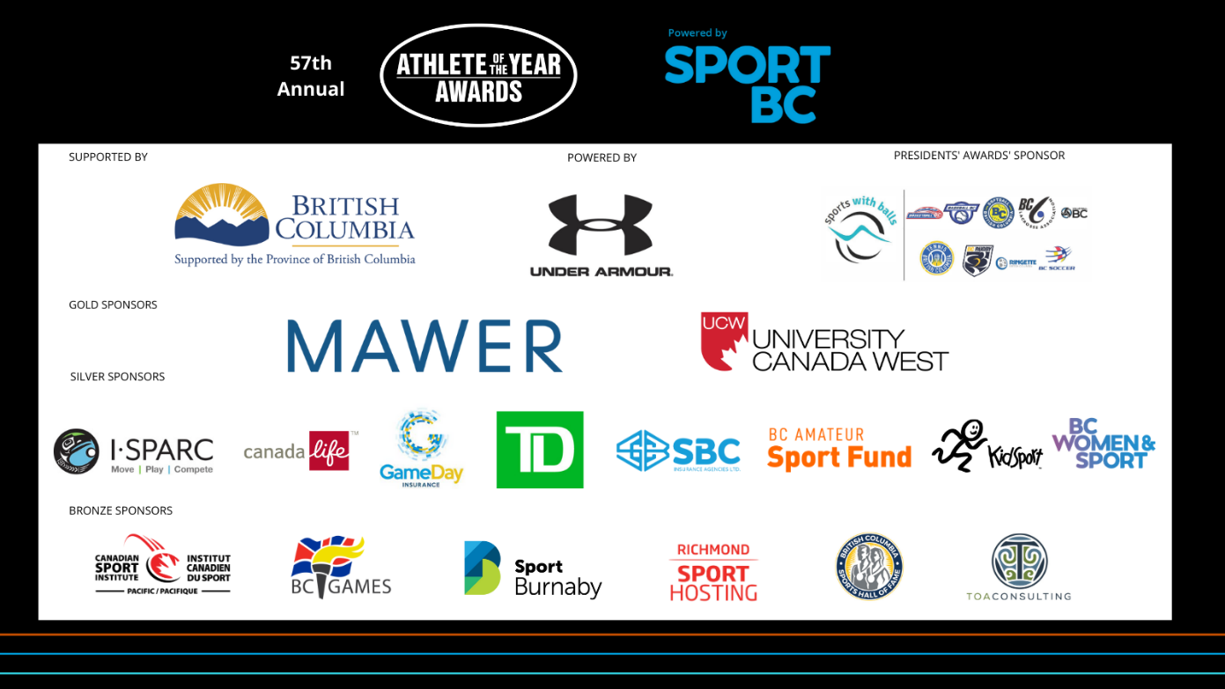

About Sport BC

Sport BC believes in the power of sport and is committed to building stronger communities through positive sport experiences. Our goal is to enhance and support sport participation in British Columbia ensuring everyone has the opportunity to thrive. Through our KidSport BC, BC Amateur Sport Fund, and BC Women & Sport along with our services Sport BC Insurance, and Payroll and Group Benefits; Sport BC supports our sixty plus member organizations. Keep up to date @SportBC

Athlete of the Year Awards Media Contact

Thursday, March 6, 2025 Allison Mailer

@SportBC Sport BC, VP Operations

#SportBC57thAOY allison.mailer@sportbc.com

778-839-8576